ROLES AND RESPONSIBILITIES

Project Title
UCAB – Cab Booking System (MERN Stack)

Objective
The Roles and Responsibilities module defines the permissions and functionalities available to different users of the UCAB system. The application follows a Role-Based Access Control (RBAC) approach where Users, Drivers, and Admins have specific responsibilities and access rights.

Introduction
The UCAB Cab Booking System consists of three primary roles:
- User (Rider)
- Driver
- Admin
Each role performs specific tasks to ensure smooth operation of the cab booking platform.

1. User (Rider)
The User is the customer who uses the application to book cab rides and manage travel activities.

Responsibilities

Registration and Login
- Create a new account.
- Login using email and password.
- Manage personal profile information.

Cab Booking
- Select pickup location.
- Select destination.
- Choose cab type.
- Confirm ride booking.

Ride Tracking
- Track assigned driver in real-time.
- View ride progress from pickup to destination.

Payment Management
- Make online payments.
- View payment receipts.
- Access transaction history.

Ride History
- View completed rides.
- Check previous booking details.
- Download ride receipts.

2. Driver
The Driver is responsible for accepting ride requests and providing transportation services.

Responsibilities

Driver Login
- Login securely into the system.
- Access assigned rides.

Ride Management
- View incoming ride requests.
- Accept or reject ride requests.
- Navigate to pickup location.

Ride Status Updates
- Update ride status:
  - Accepted
  - Started
  - In Progress
  - Completed

Earnings Management
- View daily earnings.
- Check completed rides.
- Monitor ride statistics.

Ride History
- Access previous ride records.
- View completed trip details.

3. Admin
The Admin manages the overall operation of the UCAB platform.

Responsibilities

User Management
- View registered users.
- Update user information.
- Block or remove users when required.

Driver Management
- Add new drivers.
- Verify driver information.
- Manage driver accounts.

Booking Management
- Monitor all ride bookings.
- Track ride status.
- Resolve booking issues.

Payment Monitoring
- Monitor payment transactions.
- Verify payment status.
- Generate payment reports.

Reports and Analytics
- View system reports.
- Analyze booking trends.
- Monitor platform performance.

Vehicle Category Management
- Add vehicle categories.
- Update cab types.
- Remove unused categories.
Examples:
- Mini Cab
- Sedan
- SUV
- Premium Cab

Role Relationship Diagram
+-------------+
| ADMIN |
+-------------+
| Manage All |
+------+------+
|
-----------------------------------
| |
v v
+----------------+ +----------------+
| USER | | DRIVER |
+----------------+ +----------------+
| Register/Login | | Login |
| Book Cab | | Accept Ride |
| Track Ride | | Reject Ride |
| Make Payment | | Update Status |
| Ride History | | View Earnings |
+----------------+ +----------------+

Role-Based Access Control (RBAC)
Function | User | Driver | Admin
Register/Login | Yes | Yes | Yes
Book Cab | Yes | No | No
Track Ride | Yes | Yes | Yes
Accept Ride | No | Yes | No
Update Ride Status | No | Yes | No
View Earnings | No | Yes | Yes
Manage Users | No | No | Yes
Manage Drivers | No | No | Yes
View Reports | No | No | Yes
Manage Vehicle Categories | No | No | Yes

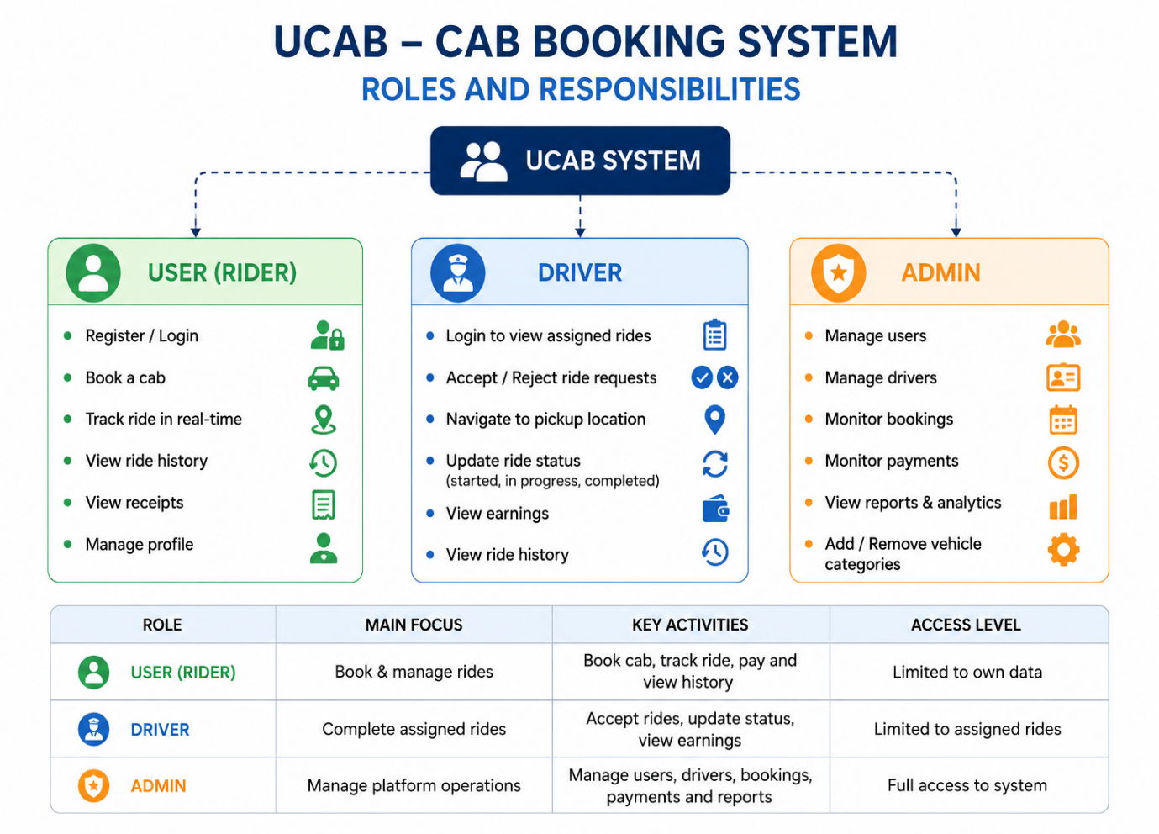

Benefits of Role-Based System
- Improved Security
- Controlled Access
- Better User Management
- Easy Maintenance
- Efficient Platform Administration
- Scalable Architecture

Conclusion
The UCAB Cab Booking System uses three major roles: User, Driver, and Admin. Each role is assigned specific responsibilities to ensure secure access, smooth ride management, efficient booking operations, and effective system administration. This role-based structure improves security, maintainability, and overall application performance.

